

**CITY UNIVERSITY**

**Mid-Term Exam**

**Course Code: CSE-325**

**Course Title: System Analysis & Design**

**Task Name**

**(i) Use Case Diagram of a Banking Management System.**

**(ii) Class Diagram of an Online Shopping System.**

**Submitted To: Richard Philip**

**Senior Lecturer, Department of CSE**

**City University, Bangladesh**

**Submitted By:**

|  |
| --- |
| **ID : 163432577**  **Name : Md. Shahiduzzaman Sakib**  **Program : CSE(Eve)**  **Batch : 44th** |

**DATE OF ASSIGNED : 20-05-2019**

**Use Case Diagram of a Banking Management System**

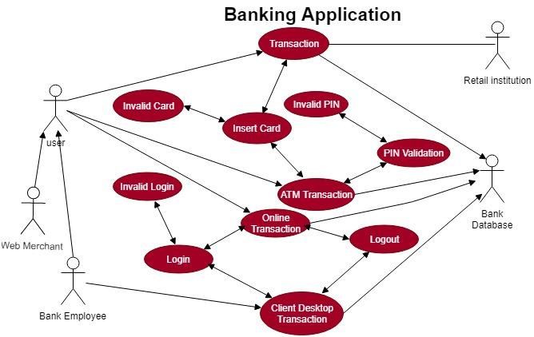

**Class Diagram of an Online Shopping System**

